February 2019

Dear Parents,

The online world is posing an ever-increasing risk to children and it is important that schools, parents and carers work together to take an active role in teaching children about online dangers and how to act safely when using the internet.

We are therefore delighted to announce that Gorran School has shown our commitment to protecting our pupils online is working with National Online Safety to deliver an interactive online workshop for all our parents & carers.

The course can be taken at your own convenience and covers:

- Information about online dangers and the newest platforms
- What online risks to look out for and how to protect your child

Please find below the URL you need to visit to register your account You will need to complete your details and select “I am a: Parent/Carer” from the dropdown:

https://lms.nationalonlinesafety.com/school/gorranschool

Once you have registered, you will be able to access the “Online Safety for Parents and Carers’ course and National Online Safety’s Resources (which includes 50+ online platform guides on the latest social media channels and games). This aims to help empower parents with the knowledge to protect their children from the dangers of the internet.

If you have any questions, or trouble accessing the course please contact support@nationalonlinesafety.com.

Yours sincerely,

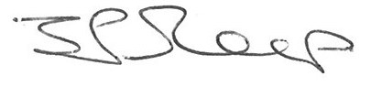

Jonathan Sleep
Head Teacher

Gorran School

