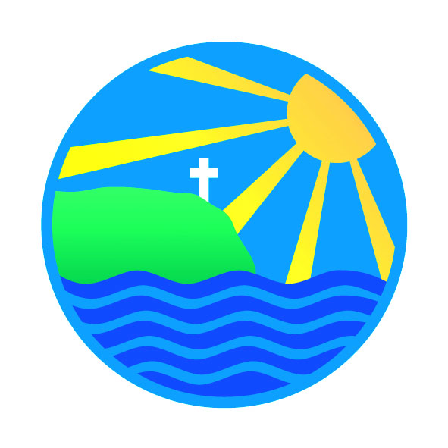
18th February 2022

 | Spring Term 2022
February
Mon 21st – Fri 25th | Spring Half Term
March
Thursday 3rd | Change of menu - please see below
Friday 4th | Zebras – Cornish Pirates rugby coaching am
Friday 11th | Zebras – Cornish Pirates rugby coaching am
Monday 14th | Science Week
Friday 18th | Zebras – Cornish Pirates rugby coaching am  Comic Relief
Wednesday 23rd | Lions ~ Cornish Pirates Rugby Festival @ St Austell RFC pm
Friday 25th | Zebras – Cornish Pirates rugby coaching am
Wednesday 30th | FunFest 22 @ The Roseland (pm)
April
Friday 1st | Zebras – Cornish Pirates rugby coaching am
Monday 4th | English Week
Friday 8th | Zebras – Cornish Pirates rugby coaching am  Last day of Spring Term
 | Summer Term 2022
Monday 25th | First day of Summer Term
May
Monday 2nd | May Day Bank Holiday – school closed
Wednesday 4th | pm ~ Balancability for Giraffes
Thursday 5th | Cross Country (TBC)
Wednesday 11th | pm ~ Balancability for Giraffes
Wednesday 18th | pm ~ Balancability for Giraffe
Wednesday 25th | pm ~ Balancability for Giraffes
Mon 30th–Fri 3rd June | Summer Half Term
June
Monday 6th | Class & Team Photos
Wednesday 8th | pm ~ Balancability for Giraffes  6-a-side Football @ St Mawes Football Club
Friday 10th | Elephants ~ Multiskills coaching
Mon 13th – Fri 17th | Lions Camp ~ Isles of Scillies
Friday 17th | Elephants ~ Multiskills coaching
Friday 24th | Elephants ~ Multiskills coaching
Wednesday 29th | Dance @ The Roseland Academy
July
Monday 4th | INSET DAY – SCHOOL CLOSED TO PUPILS
Friday 8th | Elephants ~ Multiskills coaching
Monday 11th | Sports Day ~ TBC
Tuesday 12th | Reserve Sports Day ~ TBC
Friday 15th | Elephants ~ Multiskills coaching
Monday 18th | Art Week
Friday 22nd | Elephants ~ Multiskills coaching
Friday 22nd | Last day of Summer Term
Monday 25th | INSET DAY – SCHOOL CLOSED TO PUPILS
Tuesday 26th | INSET DAY – SCHOOL CLOSED TO PUPILS
Addition/change of diary dates
Gorran Stars  of the Week  Giraffes ~ Redvers  Elephants ~ Joel  Zebras ~ William  Lions ~ James & Edward | PHSE Weekly Celebration  ‘Working hard to achieve their  goals and dreams’  Giraffes ~ Bren  Elephants ~ Jack B  Zebras ~ Guy  Lions ~ George | Gorran Stars of the Week  Giraffes ~ Ameley  Elephants ~ Teddy  Zebras ~ Senara  Lions ~ Luke

