Happy Easter 8th April 2022

 | April | Summer Term 2022
 | Monday 25th | First day of Summer Term  No afterschool clubs first week of term
 | May
 | Monday 2nd | May Day Bank Holiday – school closed
 | Tuesday 3rd | Year 6 & Reception height & weight for children that were away last time.
 | Wednesday 4th | pm ~ Balancability for Giraffes
 | Monday 9th | SATs Week
 | Wednesday 11th | pm ~ Balancability for Giraffes
 | Friday 13th | 9am ~ SEN Parent Forum
 | Monday 16th | Lions Sailing
 | Wednesday 18th | pm ~ Cross Country @ The Roseland - please note change of date  pm ~ Balancability for Giraffe
 | Monday 23rd | Lions Sailing
 | Wednesday 25th | pm ~ Balancability for Giraffes
 | Mon 30th–Fri 3rd June | Summer Half Term
 | June
 | Monday 6th | Lions Sailing  pm ~ Class & Team Photos
 | Wednesday 8th | pm ~ Balancability for Giraffes  6-a-side Football @ St Mawes Football Club
 | Friday 10th | Elephants ~ Multiskills coaching
 | Mon 13th – Fri 17th | Lions Camp ~ Isles of Scillies
 | Friday 17th | Elephants ~ Multiskills coaching
 | Monday 20th | Lions Sailing
 | Tuesday 21st | Year 6 Welcome Day @ The Roseland
 | Friday 24th | Elephants ~ Multiskills coaching
 | Monday 27th | Lions Sailing
 | Wednesday 29th | Dance @ The Roseland Academy
 | Thursday 30th | Maths Olympiad – Nexus – (4xyr5)
 | July
 | Friday 1st | INSET DAY – SCHOOL CLOSED TO PUPILS
 | Monday 4th | Lions Sailing
 | Friday 8th | Elephants ~ Multiskills coaching
 | Monday 11th | Sports Day ~ TBC
 | Tuesday 12th | Reserve Sports Day ~ TBC
 | Friday 15th | Elephants ~ Multiskills coaching
 | Monday 18th | Art Week
 | Friday 22nd | Elephants ~ Multiskills coaching
 | Friday 22nd | Last day of Summer Term
 | Monday 25th | INSET DAY – SCHOOL CLOSED TO PUPILS
 | Tuesday 26th | INSET DAY – SCHOOL CLOSED TO PUPILS
Addition/change of diary dates  Gorran Stars of the Week  Giraffes ~ Jasper  Elephants ~ Hugo  Zebras ~ William H.H.  Lions ~ Sam S &  Sam C |  |  | PHSE Weekly Celebration  ‘Keeping calm & dealing with difficult situations’  Giraffes ~ Luna  Elephants ~ Zara  Zebras ~ Freddie  Lions ~ Poppy

Afterschool Clubs ~ please note there are no afterschool clubs running the first week of the Summer Term. A new list of clubs will be published during the first week of the Summer Term.

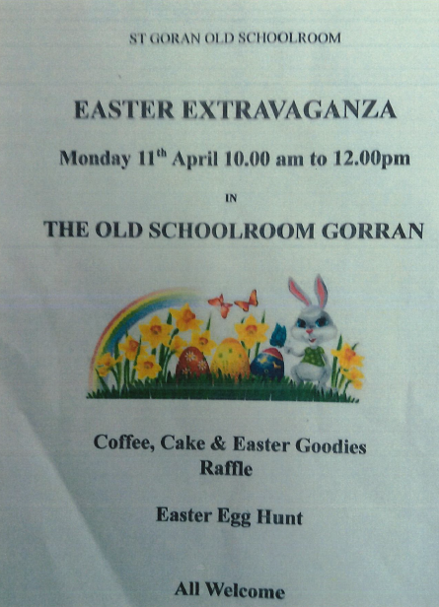

Booking Essential:
