20th May 2022

 | May | Summer Term 2022
 | Monday 23rd | Lions Sailing ~ Year 5
 | Tuesday 24th | Jubilee Street Party (please see change to menu on next page)
 | Wednesday 25th | Bags2School collection ~ 9am  Lions walk to beach  pm ~ Balanceability for Giraffes
 | Thursday 26th | pm ~ Lions cooking with Sandy (school cook) & Kris Nathan
 | Mon 30th–Fri 3rd June | Summer Half Term
 | June
 | Monday 6th | Lions Sailing ~ Year 6  pm ~ Class & Team Photos
 | Tuesday 7th | Lions ~ visit to Wheal Martyn
 | Wednesday 8th | pm ~ Balanceability for Giraffes  6-a-side Football @ St Mawes Football Club
 | Friday 10th | Elephants ~ Multiskills coaching
 | Mon 13th – Fri 17th | Lions Camp ~ Isles of Scillies
 | Friday 17th | Elephants ~ Multiskills coaching
 | Monday 20th | Lions Sailing ~ Year 5  Transition afternoon (1) for new Reception children
 | Tuesday 21st | Year 6 Welcome Day @ The Roseland  ‘Step-up Day’ for Classes & Transition afternoon (2) for new Reception Children  pm ~ RNLI visit for Zebras
 | Friday 24th | Elephants ~ Multiskills coaching
 | Monday 27th | Lions Sailing ~ Year 6
 | Tuesday 28th | Schools for All Seasons feast day ~ Lions (in school)  Transition afternoon (3) for new Reception children
 | Wednesday 29th | Dance @ The Roseland Academy
 | Thursday 30th | Maths Olympiad – Nexus – (4xyr5)
 | July
 | Friday 1st | INSET DAY – SCHOOL CLOSED TO PUPILS
 | Monday 4th | Lions Sailing ~ Year 5
 | Tuesday 5th | Transition afternoon (4) for new Reception children
 | Friday 8th | Elephants ~ Multiskills coaching
 | Monday 11th | Year 6 ~ Self Reliant Journey (TBC)
 | Tuesday 12th | Athletics @ The Roseland ~ Yrs 4, 5, 6
 | Wednesday 13th | Sports Day ~ please note change of date
 | Friday 15th | Elephants ~ Multiskills coaching
 | Monday 18th – Wednesday 20th | Zebras Camp ~ Canoe Cornwall
 | Monday 18th | Art Week  Global Boarders ~ Year 6
 | Friday 22nd | Elephants ~ Multiskills coaching
 | Friday 22nd | Last day of Summer Term
 | Monday 25th | INSET DAY – SCHOOL CLOSED TO PUPILS
 | Tuesday 26th | INSET DAY – SCHOOL CLOSED TO PUPILS
Addition/change of diary dates  Gorran Stars of the Week  Giraffes ~ Jasper & Jaxon  Elephants ~ Freddie B  Zebras ~ Florence  Lions ~ Lilly-May & Felicity |  |  | PHSE Weekly Celebration  ‘Showing respect by the way they treat others’  Giraffes ~ Jasper & Jaxon  Elephants ~ Jess  Zebras ~ Tabitha  Lions ~ Eabon

Platinum Jubilee Street Party ~ Tuesday 24th May 2022 | 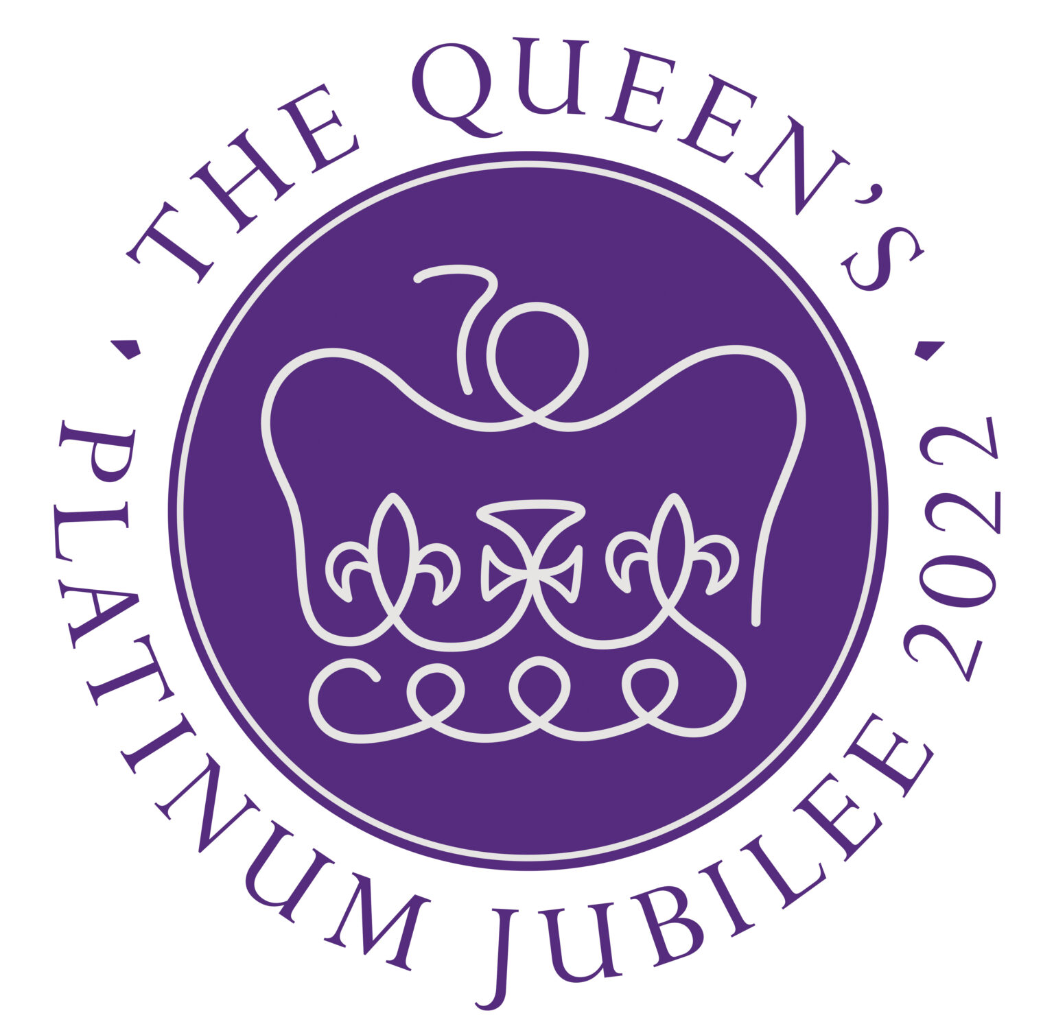
To celebrate the Queen's Platinum Jubilee we will be holding a Street Party for the whole school on Tuesday 24th May. Please can the children come dressed in their finest red, blue and white. In the morning each class will make bunting and flags to decorate the school and will make their own crowns to wear.
Sandy will be providing a special Jubilee Menu of:

Sausage Rolls
Sandwiches
Pizza
Quiche
Followed by her famous cupcakes!
Hopefully the sun will shine and this can be enjoyed outside.

Surfers Against Sewage - on 2nd July Mr Murray will be running, swimming, climbing, jumping and probably trudging 25 miles from Penzance across to the North Coast of Cornwall and then down to Land’s End during Man vs Coast 2022 in order to raise money for Surfers Against Sewage. We’re all so lucky to live in this wonderful coastal county and the work that Surfers Against Sewage do to improve our coasts is incredibly valuable to preserve our coastline and its marine life. To find out more about why Surfers Against Sewage is Mr Murray’s chosen charity and to donate, please follow the link below:

https://www.justgiving.com/fundraising/charlie-murray6?utm_source=Sharethis&utm_medium=fundraising&utm_content=charlie-murray6&utm_campaign=pfp-email&utm_term=5dd2febc0495474493c132ee2f67a838.

