27th May 2022

 | May | Summer Term 2022
 | Mon 30th–Fri 3rd June | Summer Half Term
 | June
 | Monday 6th | Lions Sailing ~ Year 6  pm ~ Class & Team Photos
 | Tuesday 7th | Lions ~ visit to Wheal Martyn
 | Wednesday 8th | pm ~ Balanceability for Giraffes  6-a-side Football @ St Mawes Football Club
 | Friday 10th | Elephants ~ Multiskills coaching
 | Mon 13th – Fri 17th | Lions Camp ~ Isles of Scillies
 | Friday 17th | SEN Parents Forum  Elephants ~ Multiskills coaching
 | Monday 20th | Lions Sailing ~ Year 5  Transition afternoon (1) for new Reception children
 | Tuesday 21st | Year 6 Welcome Day @ The Roseland  ‘Step-up Day’ for Classes & Transition afternoon (2) for new Reception Children  pm ~ RNLI visit for Zebras
 | Friday 24th | Elephants ~ Multiskills coaching
 | Monday 27th | Lions Sailing ~ Year 6
 | Tuesday 28th | Schools for All Seasons feast day ~ Lions (in school)  Transition afternoon (3) for new Reception children
 | Wednesday 29th | Dance @ The Roseland Academy
 | Thursday 30th | Maths Olympiad – Nexus – (4xyr5)
 | July
 | Friday 1st | INSET DAY – SCHOOL CLOSED TO PUPILS
 | Monday 4th | Lions Sailing ~ Year 5
 | Tuesday 5th | Transition afternoon (4) for new Reception children
 | Friday 8th | Elephants ~ Multiskills coaching
 | Monday 11th | Year 6 ~ Self Reliant Journey (TBC)
 | Tuesday 12th | Athletics @ The Roseland ~ Yrs 4, 5, 6
 | Wednesday 13th | Sports Day ~ please note change of date
 | Thursday 14th | End of year Performance ~ Matinee and evening TBC
 | Friday 15th | Elephants ~ Multiskills coaching  End of year Performance ~ evening TBC
 | Monday 18th – Wednesday 20th | Zebras Camp ~ Canoe Cornwall
 | Monday 18th | Art Week  Global Boarders ~ Year 6
 | Friday 22nd | Elephants ~ Multiskills coaching
 | Friday 22nd | Last day of Summer Term
 | Monday 25th | INSET DAY – SCHOOL CLOSED TO PUPILS
 | Tuesday 26th | INSET DAY – SCHOOL CLOSED TO PUPILS
Addition/change of diary dates  Gorran Stars of the Week  Giraffes ~ Lockie  Elephants ~ Jack B  Zebras ~ Lavinia  Lions ~ Seren |  |  | PHSE Weekly Celebration  ‘Knowing how to help themselves & other when upset’  Giraffes ~ Redvers  Elephants ~ Alfie S  Zebras ~ Millie  Lions ~ George

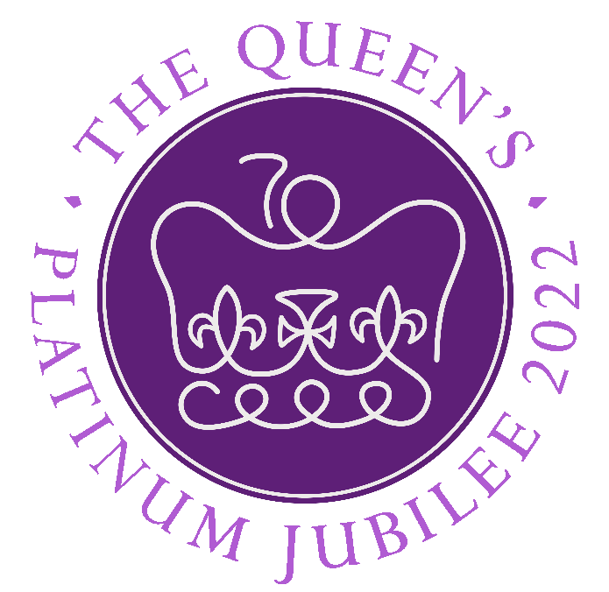 | Help needed  FRIDAY 3RD JUNE 2022 ~ Playing Field Bell Hill Jubilee Party  Are there any parents who could spare some time to help on the children’s activities stalls during the afternoon? Please could you let Mrs Sarah Male know: sarah.male@hotmail.com

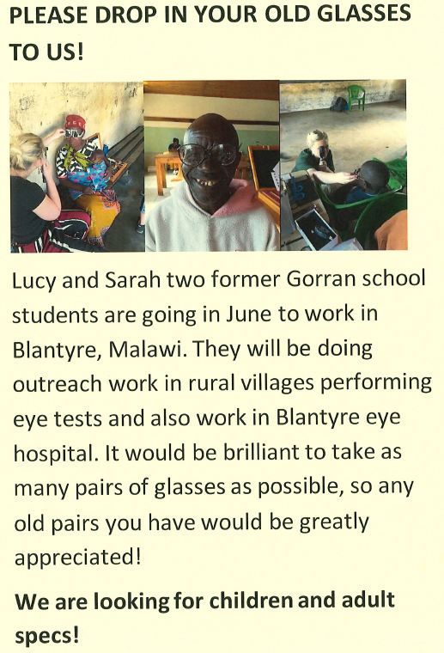

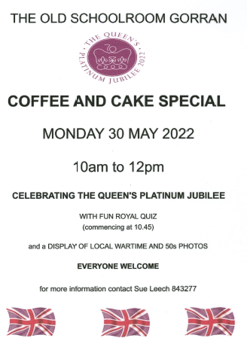

PROGRAMME OF EVENTS

Pop up to St Just Church to see the flower display open all day to view and take time for quiet reflection

MONDAY 30TH MAY
10.30 Old School Rooms Gorran Celebration Coffee Morning with a history display provided by Michael Bunney

TUESDAY 31ST MAY
2.30 Gorran Haven Village Hall Afternoon Jubilee Cream Tea and History of the Parish display.
Call Julia 07836365438 if you need a lift to attend
WEDNESDAY 1ST JUNE
Parish decorating by volunteers, flags, bunting and flowers To volunteer call David 07836365438

THURSDAY 2ND JUNE
12.30 Village Hall Gorran Haven
The Village Jubilee Lunch
To book a place (essential) call Sue 01726 844324

From 7.30 Beacon Lighting parish get together with drinks and food available from Cake Breads
Beacon will be lit at 9.45

FRIDAY 3RD JUNE
Playing Field Bell Hill Jubilee Party

2.00 Fun Dog Show
3.30 Best Crown Competition Parade ~ Children, teens & grownups
4.00 Presentation of prizes & medals
All join in choir led singing to follow
5.00 Tea Treats served in marquee
6.30 Party on the field. Music by local musician & groups, Bar, food (Pork Baps & Veg Baps) available 7.00 to 9.00 in the marquee from Cake Breads Event Closes 10.00pm

ONGOING ON THE FIELD ALL AFTERNOON
Penalty shootout organized by football club
Crown making, picture painting for children, teens & grown ups
Treasure Hunt across the field
Demo of Fishing Net Making and Willow Lobster Pot Weaving
Bar Open until late in Marquee

Gorran Bus available to and from during day

