22nd July 2022

 | Summer Term 2022
July
Monday 25th | INSET DAY – SCHOOL CLOSED TO PUPILS
Tuesday 26th | INSET DAY – SCHOOL CLOSED TO PUPILS
 | Autumn Term
September
Monday 5th | INSET DAY – SCHOOL CLOSED TO PUPILS
Tuesday 6th | School starts for Pupils  No Afterschool Clubs first week of Term
Wednesday 21st | PTA Meeting @ School (TBC)
Friday 23rd | Jeans for Genes day
Saturday 24th | DIY SOS Day (TBC)
Monday 26th | Governors Meeting
October
Friday 21st | INSET DAY – SCHOOL CLOSED TO PUPILS
Monday 24th –  Friday 28th | Half Term Week
Monday 31st | Individual Photos
November
Friday 11th | Whole School Nasal Flu
December
Friday 16th | Last day of Term
 | Spring Term
January
Tuesday 3rd | First day of Term
February
Monday 13th –  Friday 17th | Half Term Week
March
Friday 31st | Last day of Term
 | Summer Term
April
Monday 17th | First Day of Term
May
Monday 8th –  Friday 12th | KS2 SATs Week
Wednesday 10th | pm ~ Balanceability for Giraffes
Wednesday 17th | pm ~ Balanceability for Giraffes
Wednesday 24th | pm ~ Balanceability for Giraffes
Monday 29th May –  Friday 2nd June | Half Term Week
June
Wednesday 7th | pm ~ Balanceability for Giraffes
Wednesday 14th | pm ~ Balanceability for Giraffes
Wednesday 21st | pm ~ Balanceability for Giraffes
Friday 30th | INSET DAY – SCHOOL CLOSED TO PUPILS
July
Monday 24th | INSET DAY – SCHOOL CLOSED TO PUPILS
Tuesday 25th | INSET DAY – SCHOOL CLOSED TO PUPILS
Addition/change of diary dates

Thanks ~ many thanks to Jennifer and Andrew, Issy Motteram’s parents, and Wickes for the wood to mend the benches in the playground. It is very generous of them.

Wishing you all a very happy summer holiday

NO AFTER SCHOOL CLUBS FIRST WEEK OF TERM

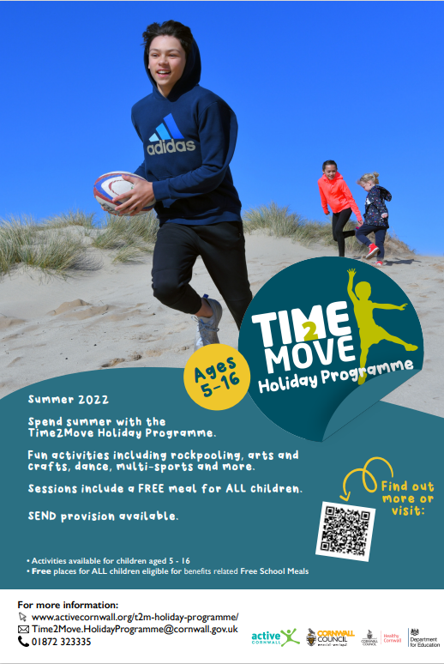

Roseland Outdoor Education Centre Crowdfunder Appeal
You may be aware that Cornwall Outdoors, the Council's outdoor education provider, ceases to trade on 31st July. The covid pandemic has given us a greater understanding of how important it is to experience the great outdoors. There is a large and rapidly growing body of evidence about the benefits of outdoor learning and play for our young people, including improved language and communication skills, motivation, independence, confidence and self-esteem, concentration, self-evaluation, creativity and openness to new perspectives.
There is an opportunity to carry on outdoor education at the former Roseland Outdoor Education Centre through its purchase from Cornwall Council. A charity has been established to provide this, the Roseland Centre (registered charity number 1186095). The charity has an Option to Purchase and are trying to raise £240,000 to enable this.
In order to do this a Crowdfunder campaign will be launched on 19th July. Ahead of the Crowdfunder over £80,000 has been pledged towards it from St Just in Roseland Parish Council and parishioners, which shows the support for, and confidence in, the project. The benefit though will be for young people from across Cornwall.
Would this be something you are able to support? If so, perhaps you could share on your social media when the Crowdfunder goes live? Perhaps you may wish to make a donation?
If you can help at all or would like further information then please contact the charity at theroselandcentre@gmail.com

From Councillor Julian German

